What is Tension?
Tension is a force along the length of a medium, especially a force carried by a flexible medium, such as a rope or cable.
Tension can be defined as an action-reaction pair of forces acting at each end of the said elements. While considering a rope, the tension force is felt by every section of the rope in both the directions, apart from the endpoints. The endpoints experience tension on one side and the force from the weight attached. Throughout the string, the tension varies in some circumstances.
Common Misconception
Tension is a pulling force and not a pushing force as ropes can’t push effectively. Attempting to push the rope will cause the rope to go slack losing the tension it possesses. This might sound obvious but while illustrating the forces acting on an object, people often draw the force of tension going in the wrong direction. Hence it is important to remember that tension can only pull on an object but not push against it.
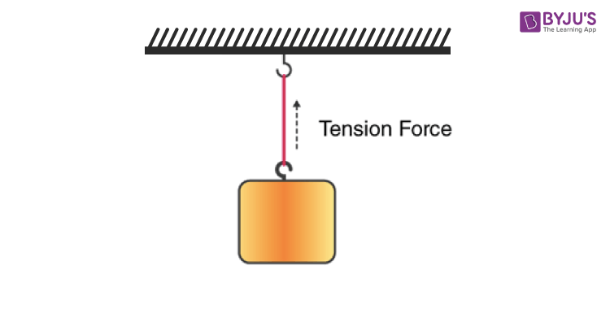
How do we calculate the force of tension?
The tension on an object is equal to the product of the mass of the object and gravitational force added to the product of the mass and acceleration. Mathematically, it is represented as follows:
T = mg + ma
Let us look at the solved example to better understand.
1. There is a 10 kg mass hanging from a rope. What is the tension in the rope if the acceleration of the mass is zero?
Solution:
We know that the force of tension is calculated using the formula T = mg + ma.
Substituting the values in the equation, we get T= (10 kg) (9.8 m/s²) + (10 kg) (0)
T = 108 N
(i)Now, assume that there is an acceleration +5 m/s² upwards. Substituting, we get T= (10 kg) (9.8 m/s²) + (10 kg) (5 m/s²)
T=148 N
(ii) Assume a downwards acceleration of a = -5m/s²
Substituting, we get T= (10 kg) (9.8 m/s²) + (10 kg) (-5)
T= 48 N

